Joins and Types:

- Inner Join – common matching records form both tables
- Full outer – Entire data from both tables
- Left outer. – common matching records form both tables + Unmatched records from left table
- right outer – common matching records form both tables + Unmatched records from right table
- left semi.
- Left anti.

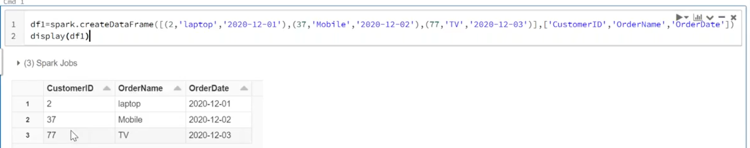
df1=spark.createDataFrame([(2,'laptop','2020-12-01'),(37,'Mobile','2020-12-02'),(77,'TV','2020-12-03')],['CustomerID','Ordername','OrderDate'])
display(df1)
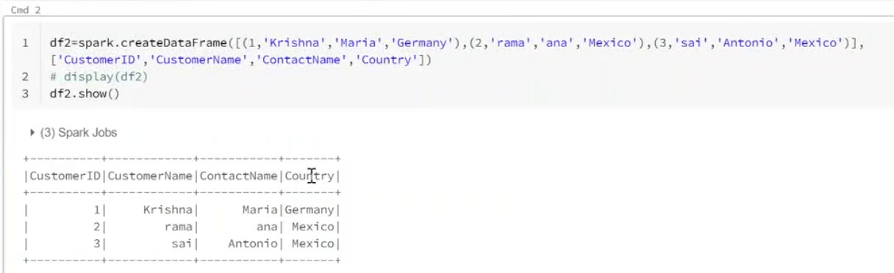
df2=spark.createDataFrame([(1,'krishna','maria','Germany'),(2,'rama','ana','mexico'),(3,'sai','antonio','mexico')],['CustomerID','CustomerName','ContactName','Country'])
display(df2)

Inner join:
#Inner join - Common matching records from both tables

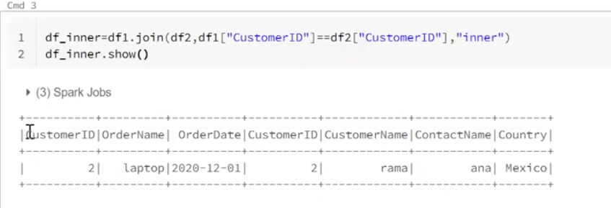
df_inner=df1.join(df2,df1["CustomerID"]==df2["CustomerID"],"inner")
df_inner.show()

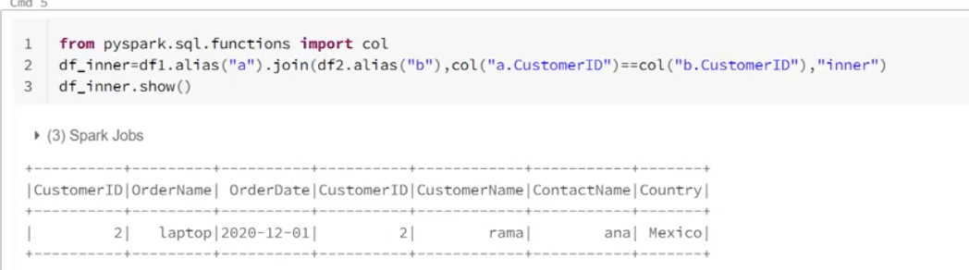
from pyspark.sql.functions import col
df_inner=df1.alias("a").join(df2.alias("b"),col("a.CustomerID")==col("b.CustomerID"),"inner")
df_inner.show()

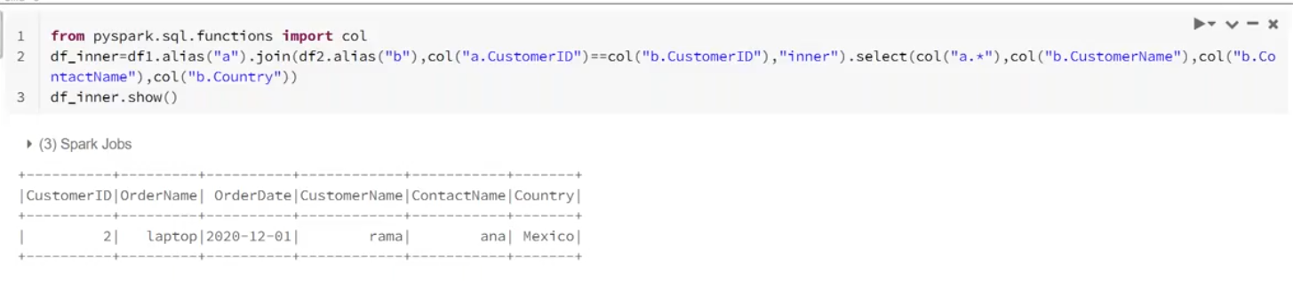
from pyspark.sql.functions import col
df_inner=df1.alias("a").join(df2.alias("b"),col("a.CustomerID")==col("b.CustomerID"),"inner").select(col("a.*"),col("b.CustomerName"),col("b.ContactName"),col("b.country"))
df_inner.show()

Left outer join
#Left outer: both tables common matching records + left table unmatching records

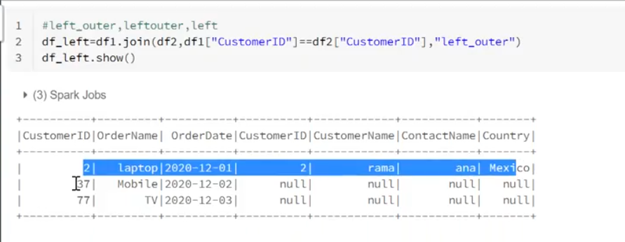
df_inner=df1.join(df2,df1["CustomerID"]==df2["CustomerID"],"left_outer")
df_inner.show()

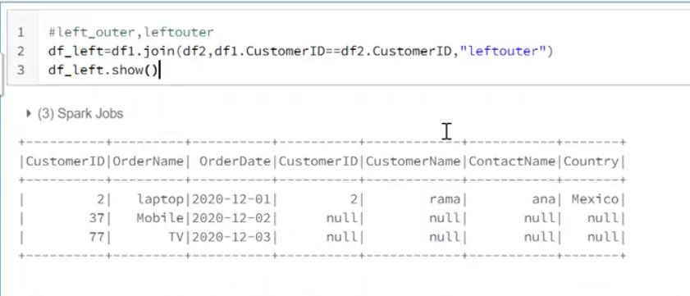
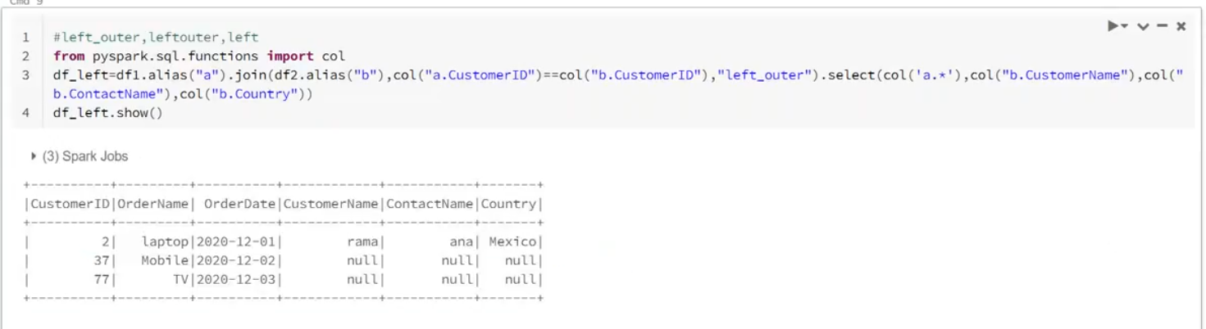
Right outer join
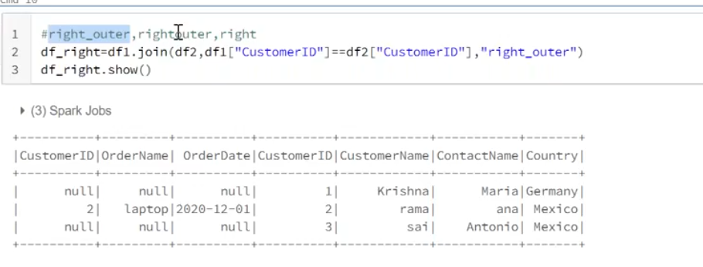
df_inner=df1.join(df2,df1["CustomerID"]==df2["CustomerID"],"right_outer")
df_inner.show()

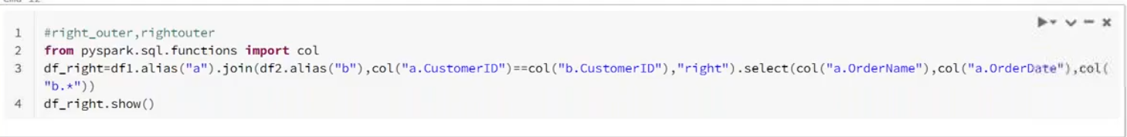
from pyspark.sql.functions import col
df_inner=df1.alias("a").join(df2.alias("b"),col("a.CustomerID")==col("b.CustomerID"),"right_outer").select(col("a.*"),col("b.CustomerName"),col("b.ContactName"),col("b.country"))
df_inner.show()

Full outer join
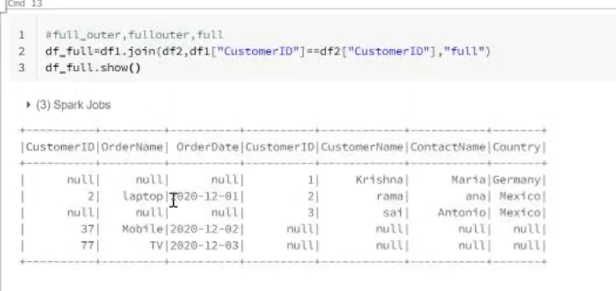
df_inner=df1.join(df2,df1["CustomerID"]==df2["CustomerID"],"full")
df_inner.show()

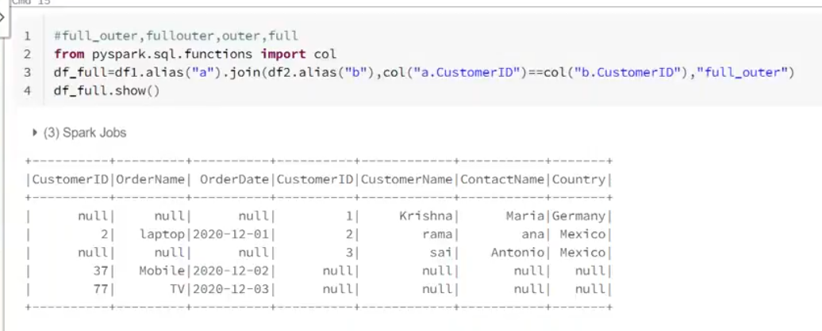
from pyspark.sql.functions import col
df_inner=df1.alias("a").join(df2.alias("b"),col("a.CustomerID")==col("b.CustomerID"),"full").select(col("a.*"),col("b.CustomerName"),col("b.ContactName"),col("b.country"))
df_inner.show()

Left semi – it will display common matching records from the both tables and left table having common records it will display, not other records from the left table means unmatched records
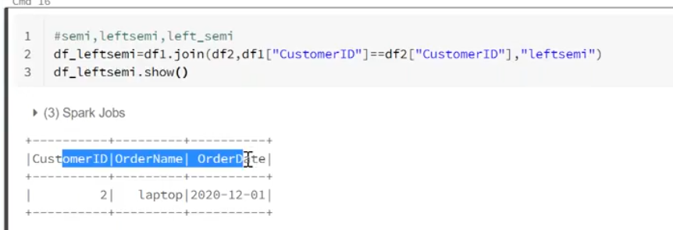
df_inner=df1.join(df2,df1["CustomerID"]==df2["CustomerID"],"left_semi")
df_inner.show()

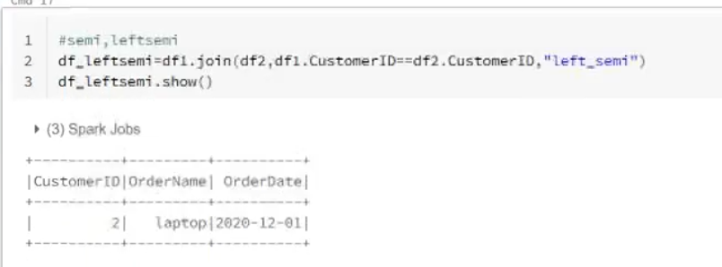
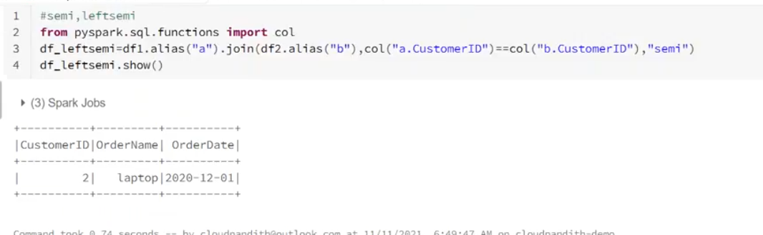
from pyspark.sql.functions import col
df_inner=df1.alias("a").join(df2.alias("b"),col("a.CustomerID")==col("b.CustomerID"),"semi")
df_inner.show()

Left anti – it will display unmatched records from the left table
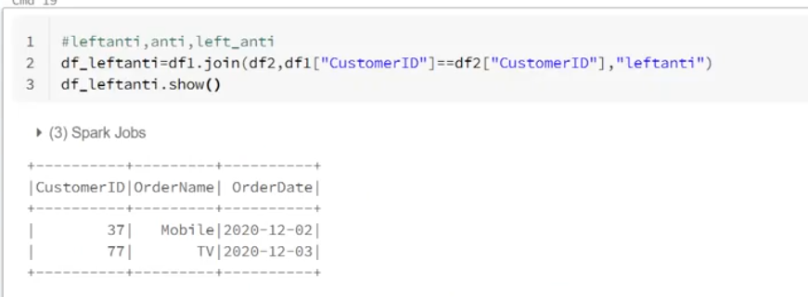
df_inner=df1.join(df2,df1["CustomerID"]==df2["CustomerID"],"left_anti")
df_inner.show()

from pyspark.sql.functions import col
df_inner=df1.alias("a").join(df2.alias("b"),col("a.CustomerID")==col("b.CustomerID"),"left_anti")
df_inner.show()

